**Noise Pollution Monitoring: Phase 4**

**Step1:**

**Define Project Requirements:**

Start by defining the specific requirements for your IoT noise pollution monitoring project. These could include the target area, acceptable noise levels, data collection intervals, and the desired output format. Your project requirements will guide your entire project.

**Step2:**

**Hardware Setup:**

For noise pollution monitoring, you'll need appropriate hardware. Here's a list of components you

* **might need:** Noise Sensors: Choose suitable noise sensors or microphones capable of capturing audio data.
* **Microcontroller**: Select a microcontroller (e.g., Arduino, Raspberry Pi) to interface with the noise sensors.
* **Connectivity Module:** You'll need a connectivity module (Wi-Fi, GSM, or LoRa) to transmit data to a central server.
* **Power Supply:** Ensure that you have a reliable power supply, whether through batteries, solar panels, or a constant electrical source.
* **Enclosure:** Design an enclosure to protect the hardware from environmental conditions.

**Step 3:**

**Software Development:**

Develop the software for your IoT project, including the following components:

* **Sensor Interface:** Write code to read data from the noise sensors through the microcontroller.
* **Data Transmission**: Develop code for data transmission to a central server. You can use HTTP, MQTT, or other protocols.
* **Server Backend:** Create a server that receives and stores the data. You might use technologies like Node.js, Python, or a cloud service (e.g., AWS, Azure).
* **Database:** Set up a database (e.g., MySQL, PostgreSQL, MongoDB) to store the collected noise data.
* **Web Interface**: Design a web interface to display real-time and historical noise data. Use HTML, CSS, and JavaScript for the frontend and a web framework (e.g., Django, Flask, Express) for the backend.

**Step 4:**

**Data Analysis and Visualization:**

* Implement data analysis algorithms to process the collected noise data. This could involve identifying patterns, calculating averages, and generating alerts when noise levels exceed thresholds. Use data visualization libraries like D3.js or Plotly to create interactive graphs and charts for data presentation.

**Step 5:**

**User Authentication and Security:**

* Ensure that your IoT project has proper user authentication mechanisms to access noise data securely. Implement security best practices, like encryption and authorization, to protect the data and system.

**Step 6:**

**Documentation:**

Create thorough documentation for your project. This documentation should include:

* Hardware assembly instructions.
* Software setup and configuration.
* User guides for accessing and interpreting noise data.
* Security protocols and data privacy policies.

**Step 7:**

**Testing and Calibration:**

* Before deploying your IoT noise pollution monitoring system, thoroughly test the hardware and software components. Calibrate the sensors to ensure accurate data collection.

**Step 8:**

**Deployment:**

* Once you're satisfied with the testing, deploy your IoT system in the target area. Ensure that it's properly sealed and secured against environmental conditions.

**Step 9:**

**Continuous Monitoring and Maintenance:**

* Regularly monitor the system to ensure it's collecting data as expected. Perform maintenance as needed, such as battery replacement or software updates.

**Step 10:**

**Data Sharing and Reporting:**

* Share your noise pollution data with relevant authorities or the public, as per project requirements. Create periodic reports and share them as needed.

**MOBILE APP DEVELOPMENT:**

To connect your IoT noise pollution monitoring project with a mobile app, you will need to develop a mobile application that can communicate with your IoT system through a network connection. Here's a high-level overview of the steps involved:

**Mobile App Development:**

* Choose a mobile app development platform (e.g., Android, iOS, or both) and select the programming language and framework (e.g., Java/Kotlin for Android, Swift/Objective-C for iOS, or cross-platform frameworks like React Native or Flutter).
* Develop the mobile app that will be used to interact with your IoT noise pollution monitoring system. The app should have a user-friendly interface for viewing real-time noise data, historical data, and setting alerts.
* Implement user authentication and authorization mechanisms to ensure that only authorized users can access the data and control the system.

**Network Communication:**

* Implement communication protocols between your mobile app and the IoT system. You can use common IoT protocols like MQTT or HTTP for data exchange.
* Set up API endpoints on your IoT server for the mobile app to access data and send commands. Implement secure and authenticated communication to protect the data.

**Real-Time Data Display:**

* Create a section in your mobile app to display real-time noise data from your IoT system. You can use charts or graphs to visualize this data.
* Implement mechanisms for real-time updates, such as WebSocket or long polling, to provide users with up-to-the-minute information.

**Historical Data Access:**

* Add a feature in your mobile app that allows users to access historical noise data. Users should be able to specify date ranges and view past data trends.

**Alerts and Notifications:**

* Integrate push notifications in your mobile app to alert users when noise levels exceed certain thresholds. Users should be able to set and customize alert parameters.

**User Interaction:**

* Enable users to control certain aspects of the IoT system through the mobile app. For example, users might be able to adjust sensor settings, configure alerts, or access specific reports.

**Mobile App Testing:**

* Test the mobile app thoroughly on different devices and platforms to ensure it works correctly and is user-friendly.

**Deployment:**

* Publish the mobile app on app stores (Google Play Store for Android or Apple App Store for iOS).

**User Training and Support:**

* Provide training or user guides to help users install and use the mobile app effectively.

User Feedback and Updates:

* Collect feedback from users and continuously update the mobile app to improve its functionality and address any issues.

**PROGRAM:**

To create a Python program for connecting your IoT noise pollution monitoring project to a mobile app, you'll typically use a Python web framework like Flask or Django to build a RESTful API that can be accessed by your mobile app. Here's a simplified example of how to create a basic Flask-based API:

Install Required Libraries:

First, ensure you have Flask installed. You can use pip to install it:

**pip install flask**

Create a Python Flask Application:

Create a Python script (e.g., app.py) to set up your Flask application:

**from flask import Flask, request, jsonify**

**app = Flask(_name_)**

**# Simulated data; replace with your actual data source**

**noise_data = {**

**'current_noise': 70, # Example current noise level**

**'historical_data': [60, 65, 70, 75, 80], # Example historical data**

**}**

**@app.route('/api/noise/current', methods=['GET'])**

**def get_current_noise():**

**return jsonify({'current_noise': noise_data['current_noise']})**

Run the Flask application by executing the script:

**python app.py**

Your API is now running and accessible at http://localhost:5000/api/noise/current and http://localhost:5000/api/noise/historical.

Connect the Mobile App:

In your mobile app development, you can use libraries like requests (for Python) or built-in networking libraries (e.g., URLSession for iOS, HttpURLConnection for Android) to make HTTP requests to these API endpoints.

Here's an example of how to retrieve current noise data in Python using the requests library:

**import requests**

**url = "http://localhost:5000/api/noise/current"**

**response = requests.get(url)**

**if response.status_code == 200:**

**data = response.json()**

**current_noise = data['current_noise']**

**print(f"Current Noise Level: {current_noise} dB")**

**else:**

**print("Failed to retrieve data.")**

Adapt this code to your mobile app's programming language and framework to access the API endpoints and display the data.

**Circuit Diagram For Noise Pollution:**

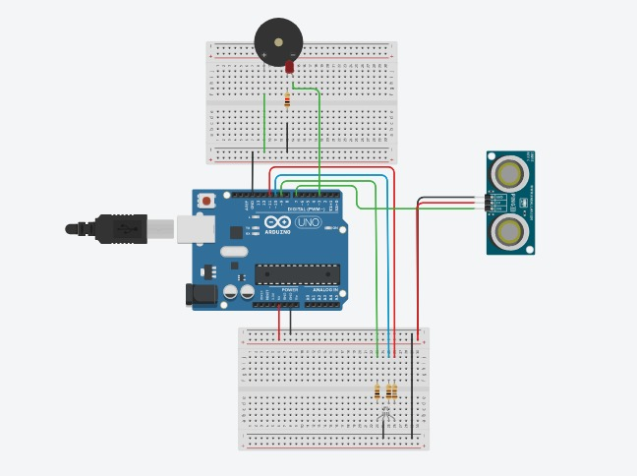

3-D Representation for Noise Pollution Monitoring:

